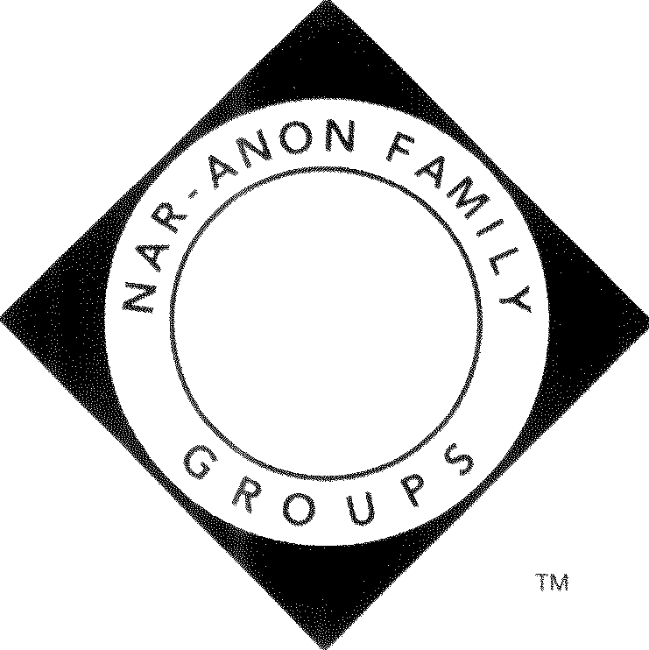
Nar-Anon Family Group Headquarters, Inc.
WORLD SERVICE OFFICE

Date: July 5, 2022

To: Nar-Anon Regional Service Committees

CC: Regional Delegates/Alternates
National Service Offices

From: Nar-Anon Board of Trustees

Subject: WSC 2023 – “Progress Through Worldwide Unity”

The Board of Trustees looks to our Nar-Anon principles in our decision making. The First Tradition tells us our common welfare should come first. The Third Concept of Service states “The Nar-Anon Family Groups delegate to the service structure the authority necessary to fulfill the responsibilities assigned to it”.

To fulfill our responsibility to the Nar-Anon fellowship a decision has been made to conduct the WSC 2023 by means of virtual technology. Restrictions on travel and our current financial situation make this the best decision for the fellowship.

The virtual conference will have a cost and the WS Conference Committee will be sending out a letter to all the regions with the cost of the equalized expense. Because many face-to-face meetings are still shut down, donations are down, as well as literature sales. WSO is still working and mailing out literature and helping families of addict looking for meetings.

The worldwide regions which plan to have a delegate and/or alternate delegate attend conference, should send the payment as detailed from the WS Conference Committee. The Board of Trustees is asking the regions to consider a motion and a conscience of your assembly to donate funds in the treasury over your prudent reserve to Nar-Anon Family Group, Headquarters Inc.
.

23110 Crenshaw Boulevard, Suite A I Torrance, CA 90505 I Toll Free (800) 477-6291 I Local (310) 534-8188
For the families and friends of addicts. I 501(c)(3) Non-Profit

